TOTHBOT
KRAKEN SYSTEM ARCHITECTURE OVERVIEW
The Complete System — All Architectural Decisions + All Flow Diagrams
DocDCN: | 0500000
DocTitle: | TothBot_Kraken_System_Architecture_Overview
DocVersion: | dv1_3
DocOwner: | Bill
DocPath: | GitHub.com/TothBot/TothBot-V2-Docs/05XXXXX_System_Architecture/0500000_System_Architecture_Overview_dv1_3.docx
DocDate: | 03-24-2026
DocTime: | 15:00:00 UTC

PURPOSE This document captures all architectural decisions, FP/DP analyses, and system specifications from the TothBot Kraken architecture sessions of March 2026. Includes all six system flow diagrams showing connections between Kraken, TothBot, and CIATS as one unified organism.

Diagrams in this document:
Diagram 1 — Kraken API Connection Architecture (triple-verified)
Diagram 2 — TothBot Trading Pipeline (all 6 FP/DP improvements applied)
Diagram 3 — Exit Architecture: Ground Zero Redesign for Kraken
Diagram 4 — Regime Taxonomy: 6-Regime Grid + Two-Level Tagging
Diagram 5 — CIATS Architecture: Data Flows and Improvement Cycle
Diagram 6 — Complete System: One CIATS-Owned Organism

1. System Identity and Mission

1.1 What TothBot Is
TothBot is an automated cryptocurrency spot trading system on Kraken exchange. It runs 24/7/365 on a Hetzner VPS, processes 5-minute OHLC candle close events as its system clock, and executes long-only trades using a momentum-based signal engine.
TothBot is not an external system connected to Kraken — it IS Kraken's event processor. Every action is a response to a Kraken push event. No timers. No polling. Idle and silent until Kraken speaks.

1.2 The One Organism Principle
Three functional zones, one organism:
· Kraken: generates events, executes orders, holds resting TP limit orders and off-book emergency SL stop orders on matching engine
· TothBot: processes Kraken events, executes trading strategy, manages positions
· CIATS: learns from event records, continuously improves processing rules

PRIMARY MISSION Maximize profit. Minimize loss. With an emphasis on minimizing loss. Loss prevention takes priority over profit generation. Everything else is secondary.

1.3 Operating Environment

Parameter | Value
Exchange | Kraken Spot (Long Module — Short deferred)
Language | Python 3.12.3
VPS | Hetzner CPX22 — 87.99.141.44 — Ashburn VA
System Clock | Kraken OHLC 5-minute candle close event (WS v2 push)
Fee Baseline | Maker 0.16% / Taker 0.26% (CIATS monitors actuals)
Operation | 24/7/365 — CIATS may add stand-down periods via PDCA if data supports
Starting Portfolio | $1,000 Long Module
Sacred constraint | Net 1:1.5 R:R — hardcoded — the only number not owned by CIATS

2. Kraken API Connection Architecture
All connection points verified across three independent analysis passes (15 total sources). The diagram below shows the complete interface between TothBot and Kraken with all data flows.

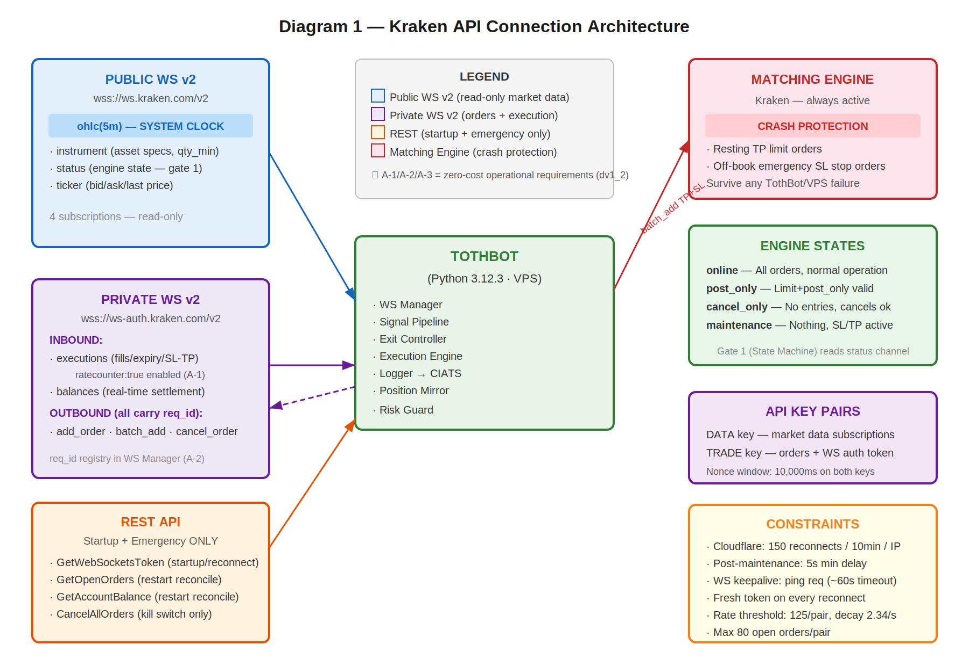

2.1 Key Connection Points
· Public WS v2: instrument (asset specs) · status (engine state) · ohlc-5m (system clock) · ticker (price data)
· Private WS v2 inbound: executions (fills/expirations/SL-TP triggers, ratecounter:true enabled — see Section 2.4) · balances (real-time settlement)
· Private WS v2 outbound: add_order (entry) · batch_add (SL+TP atomic) · cancel_order (exit leg cleanup) — all messages carry req_id (see Section 2.4)
· REST: only GetWebSocketsToken (startup/reconnect) · GetOpenOrders + GetAccountBalance (restart reconcile) · CancelAllOrders (kill switch emergency)
· Matching Engine: resting TP limit orders and off-book emergency SL stop orders survive any TothBot failure independently — crash protection

2.2 Four Kraken Engine States

State | TothBot Behavior
online | All orders. Signal pipeline runs normally.
post_only | TothBot limit+post_only entries ARE valid. Trading continues.
cancel_only | No new entries. Exit Controller can cancel. Resting TP and off-book SL stop orders active.
maintenance | No orders, no cancels, no matching. Resting TP and off-book SL stop orders active on engine.

2.3 API Rate Limits — Intermediate Tier (C-2)
Rate limits are shared across REST, WebSockets, and FIX — there is no separate per-protocol budget.

Parameter | Intermediate Tier Value
Rate counter threshold (per pair) | 125
Rate counter decay (per second) | 2.34
Max open orders (per pair) | 80
Add order fixed cost | +1
Batch add fixed cost | +(n/2) where n = orders in batch
Cancel order cost (< 5s old) | +8
Cancel order cost (< 10s old) | +6
Cancel order cost (< 300s old) | +1

Operational note: At Layer 2 MAE exit, the Exit Controller cancels both TP and emergSL before market-selling. Cancel cost depends on how long those orders have been resting. TP and emergSL are placed at entry fill — cancel at MAE breach is typically seconds to minutes later. The 125 threshold per pair with 2.34/sec decay provides substantial headroom at TothBot's 5-minute candle frequency. Full rate limit specification and CIATS monitoring hooks to be documented in 0411003.

2.4 WS Operational Requirements (A-1, A-2, A-3)
Three zero-cost operational requirements derived from WS v2 capabilities already on the wire:

A-1 — Rate counter monitoring via executions channel:
The executions subscription accepts ratecounter: true. When enabled, the real-time rate counter value per pair is included in the stream at zero additional connection cost. CIATS Stream 1 EWMA Monitor must add rate_counter_by_pair as a third monitoring signal alongside the existing rejection_rate_by_regime (Finding 6). High or rising rate counter in a pair = early warning of execution pressure. To be specified in 0511003 (Execution Engine) and 0211001 (CIATS).

A-2 — req_id on all outbound WS messages:
All WS v2 requests accept an optional client-specified integer req_id for correlating requests to responses. All outbound WS messages from TothBot must carry a unique req_id: add_order, batch_add, cancel_order, amend_order (future), and ping. The WS Manager must maintain a pending-request registry, match each response to its originating request by req_id, and trigger an alert on any unacknowledged message after a defined timeout. Without this, TothBot cannot confirm that a batch_add (TP + emergSL) was successfully received and acknowledged. This is a correctness requirement, not a monitoring enhancement. To be specified in 0511001 (WS Manager).

A-3 — Round-trip latency monitoring via time_in/time_out:
All WS v2 responses include time_in (server receipt timestamp) and time_out (server send timestamp) to nanosecond precision. The Logger must record these fields on all WS responses. CIATS Stream 1 EWMA Monitor must add ws_roundtrip_latency_ms as a monitoring signal. A degrading latency trend is an early warning of VPS network degradation or Kraken infrastructure stress. Zero additional connections or subscriptions required. To be specified in 0511006 (Logger) and 0211001 (CIATS).

3. TothBot Trading Pipeline
The pipeline fires on every 5-minute OHLC candle close event. It is synchronous and event-driven. All 6 FP/DP validated improvements are incorporated. ★ marks new additions.

NOTE — OHLC fires on trade events, not wall clock: The OHLC channel publishes an updated candle only when a trade occurs in that interval. If no trades occur after an interval border, no candle message is sent until the next trade. The Liquidity Gate ($500k/day minimum) materially reduces this risk. However, TothBot must handle the possibility of a delayed or stalled system clock for a pair that becomes temporarily illiquid. To be addressed in 0511002 Signal Pipeline Specification.

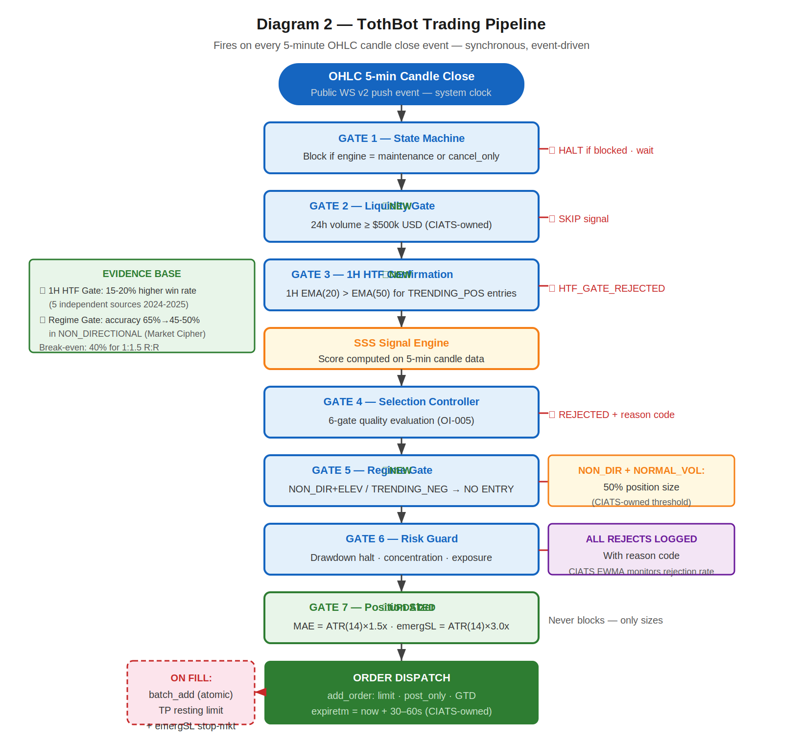

3.1 Gate Summary

Gate | Name | Blocks When
1 | State Machine | Kraken engine is maintenance or cancel_only
2 | Liquidity Gate ★ NEW | Asset 24h volume < $500k USD
3 | 1H HTF Confirmation ★ NEW | 1H EMA(20) ≤ EMA(50) for TRENDING_POSITIVE entries
4 | Selection Controller | Signal fails any of 6 quality gates
5 | Regime Gate ★ NEW | NON_DIR+ELEVATED or TRENDING_NEGATIVE regime
6 | Risk Guard | Drawdown halt triggered, concentration exceeded, exposure limit
7 | Position Sizer ★ UPDATED | ATR(14)×1.5x MAE, ATR(14)×3.0x emergSL — never blocks, just sizes

EVIDENCE BASE — 1H HTF Gate and Regime Gate 15-20% higher win rates with daily+hourly confirmation (5 independent sources 2024-2025). Market Cipher: accuracy drops 65% in trending to 45-50% in NON_DIRECTIONAL conditions. Trading where edge is absent violates the primary mission of loss minimization.

4. Exit Architecture — Ground Zero Redesign for Kraken
This exit architecture was rebuilt from zero for Kraken. It eliminates all competing exit strategies. The Exit Controller owns all normal exits. The Kraken off-book emergency SL stop order is crash protection only.

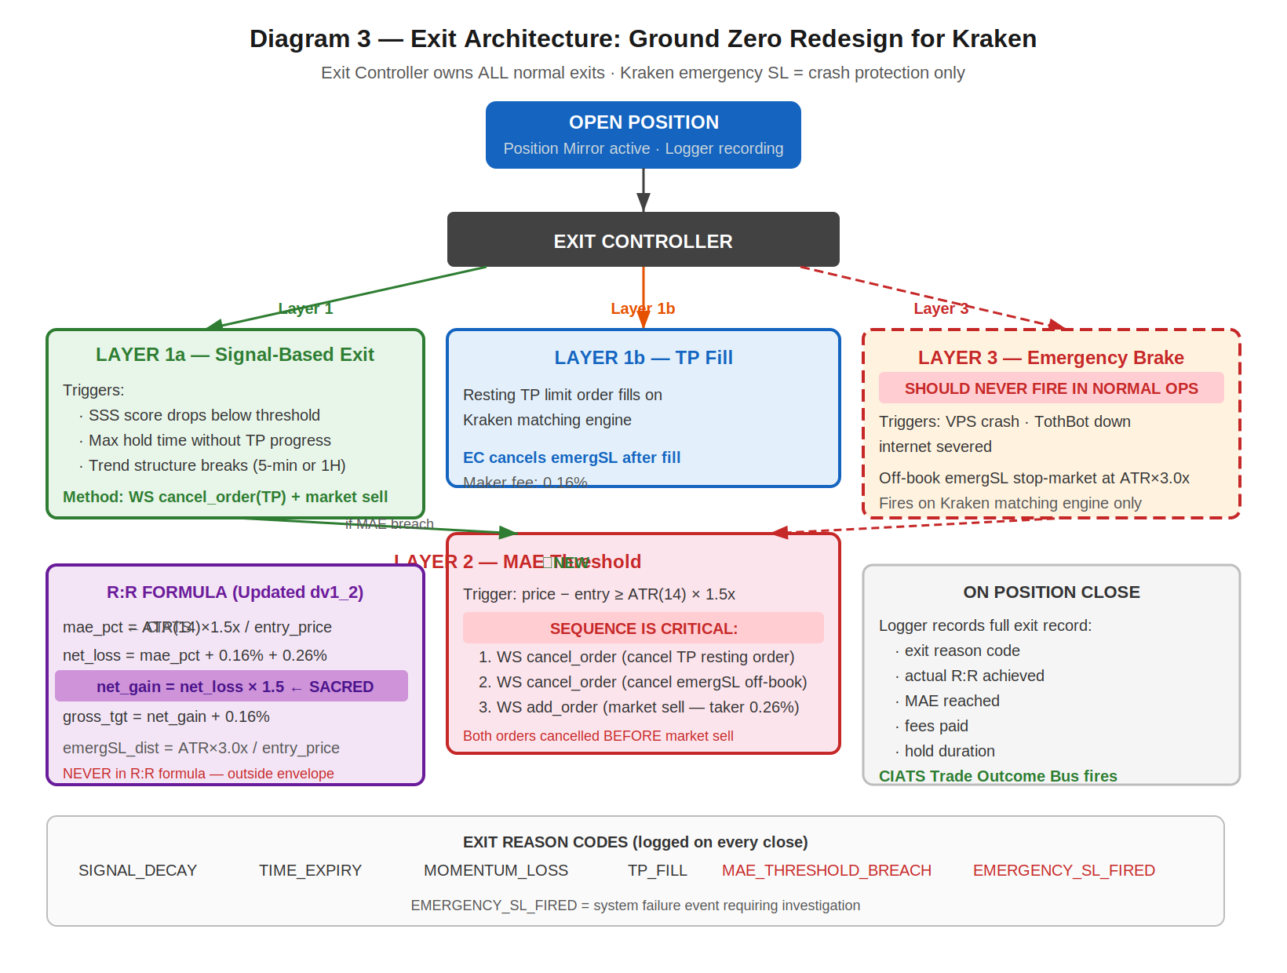

4.1 Three-Layer Summary

Layer | Name | When It Fires
1a | Signal-Based Exit | Signal decay · time expiry · momentum loss. WS cancel TP + market sell.
1b | TP Fill | Resting TP limit on Kraken matching engine fills. EC cancels SL.
2 | MAE Threshold (★) | price-entry ≥ ATR(14)×1.5x. EC cancels TP+SL FIRST then market sell.
3 | Emergency Brake (★) | VPS/TothBot/internet failure ONLY. Off-book emergency SL stop order at ATR(14)×3.0x fires on Kraken matching engine. NEVER in normal operation.

4.2 R:R Formula (Updated)

mae_pct = ATR(14) x 1.5x / entry_price (CIATS-owned 1.5x multiplier)
net_loss = mae_pct + 0.16% + 0.26% (entry maker + MAE taker exit)
net_gain = net_loss x 1.5 (SACRED — hardcoded)
gross_target = net_gain + 0.16% (TP maker exit)
emergSL_dist = ATR(14) x 3.0x / entry_price (NEVER in R:R formula — outside envelope)

5. Regime Taxonomy
The six-regime grid is the foundation of CIATS regime-segmented analysis. Every trade is tagged with both asset_regime and market_regime (BTC proxy). Computed daily at 00:00 UTC.

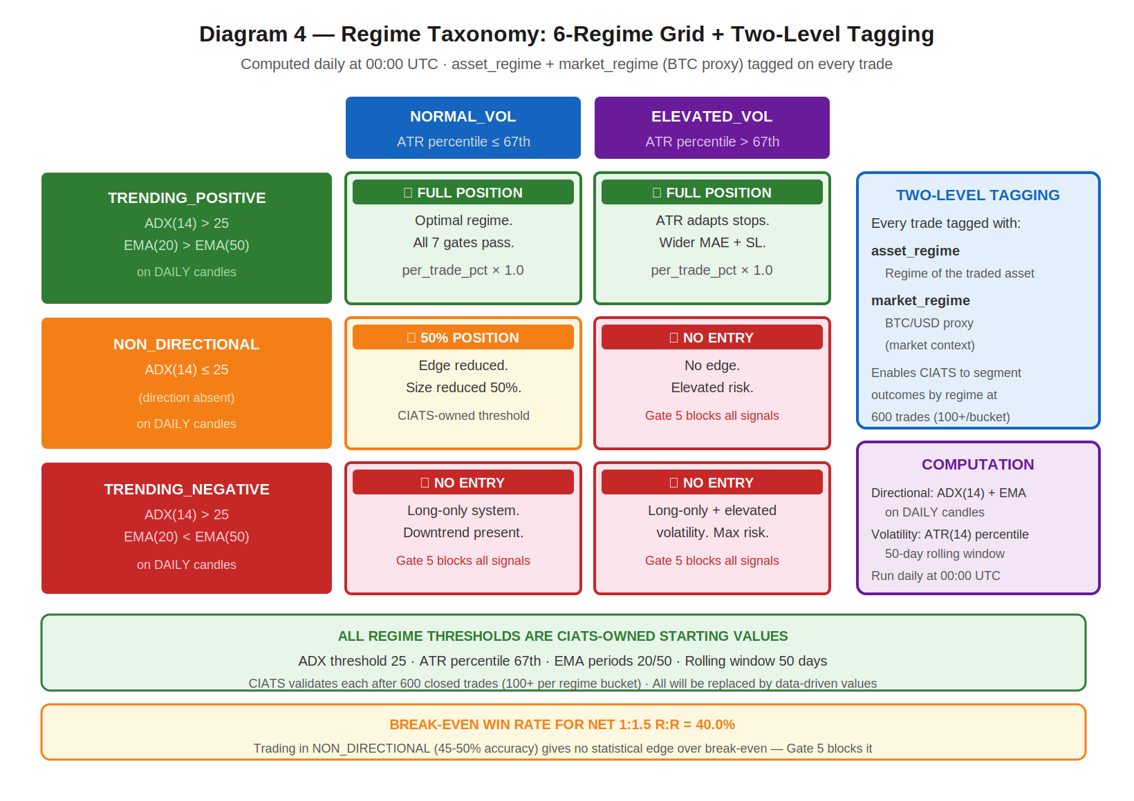

5.1 Computation

Directional state: ADX(14) + EMA(20) vs EMA(50) on DAILY candles
Volatility state: ATR(14) percentile rank in 50-day rolling window

TRENDING_POSITIVE: ADX(14) > 25 AND EMA(20) > EMA(50)
TRENDING_NEGATIVE: ADX(14) > 25 AND EMA(20) < EMA(50)
NON_DIRECTIONAL: ADX(14) <= 25
NORMAL_VOL: ATR percentile <= 67th
ELEVATED_VOL: ATR percentile > 67th
asset_regime + market_regime (BTC/USD proxy) both tagged on every trade

ALL REGIME THRESHOLDS ARE CIATS-OWNED ADX threshold 25, ATR percentile 67th, EMA periods 20/50, rolling window 50 days — all starting values. CIATS validates each after 600 closed trades (100+ per regime bucket).

6. CIATS Architecture and Data Flows
CIATS is fully asynchronous. It never blocks the trading critical path. It reads only from the Logger and writes only to the Parameter Store. Deming PDCA governs every change.

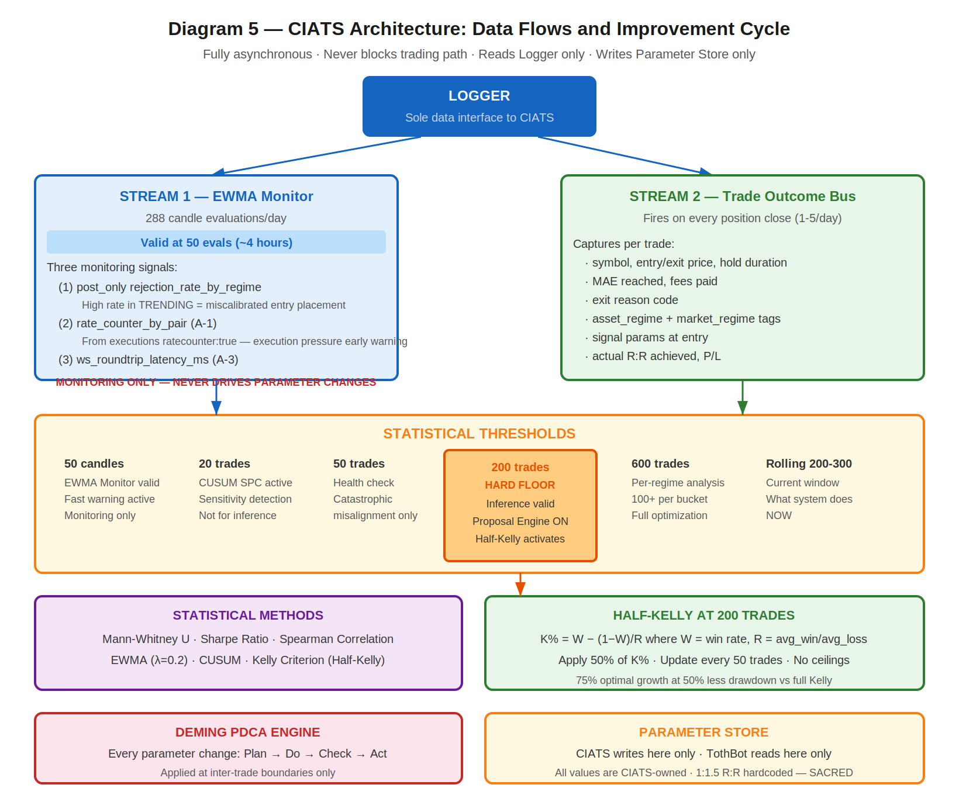

6.1 Two Data Streams

Stream | Description
Stream 1: EWMA Monitor | 288 candle evals/day. Valid at 50 evals (~4 hrs). Detection within ~22 observations. Three monitoring signals: (1) post_only rejection_rate_by_regime (Finding 6), (2) rate_counter_by_pair from executions channel (A-1), (3) ws_roundtrip_latency_ms from WS response timestamps (A-3). Monitoring signals ONLY — never drives parameter changes.
Stream 2: Trade Outcome Bus | Fires on each position close. Captures: symbol, entry/exit price, hold duration, MAE reached, fees, exit reason, both regime tags, signal params at entry, actual R:R, P/L.

6.2 Statistical Thresholds

Threshold | Purpose
50 candle evals | EWMA Monitor valid. Fast warning stream active. Monitoring only.
20 trades | CUSUM SPC trade-level. Sensitivity detection. Not for inference.
50 trades | Health check. Detect catastrophic misalignment only.
200 trades — HARD FLOOR | Inference valid. Proposal Engine activates. Half-Kelly replaces fixed 5%.
600 trades | Per-regime analysis: 100+ per bucket. Full regime-segmented optimization.
Rolling 200-300 | Current performance window — what the system is doing NOW.
Full corpus | Zero-cost historical library. Grows perpetually. Regime comparison.

7. Complete System: One CIATS-Owned Organism
This diagram shows all three zones — Kraken, TothBot, and CIATS — as a single unified organism. Every flow and connection point is shown. ★ marks FP/DP validated additions.

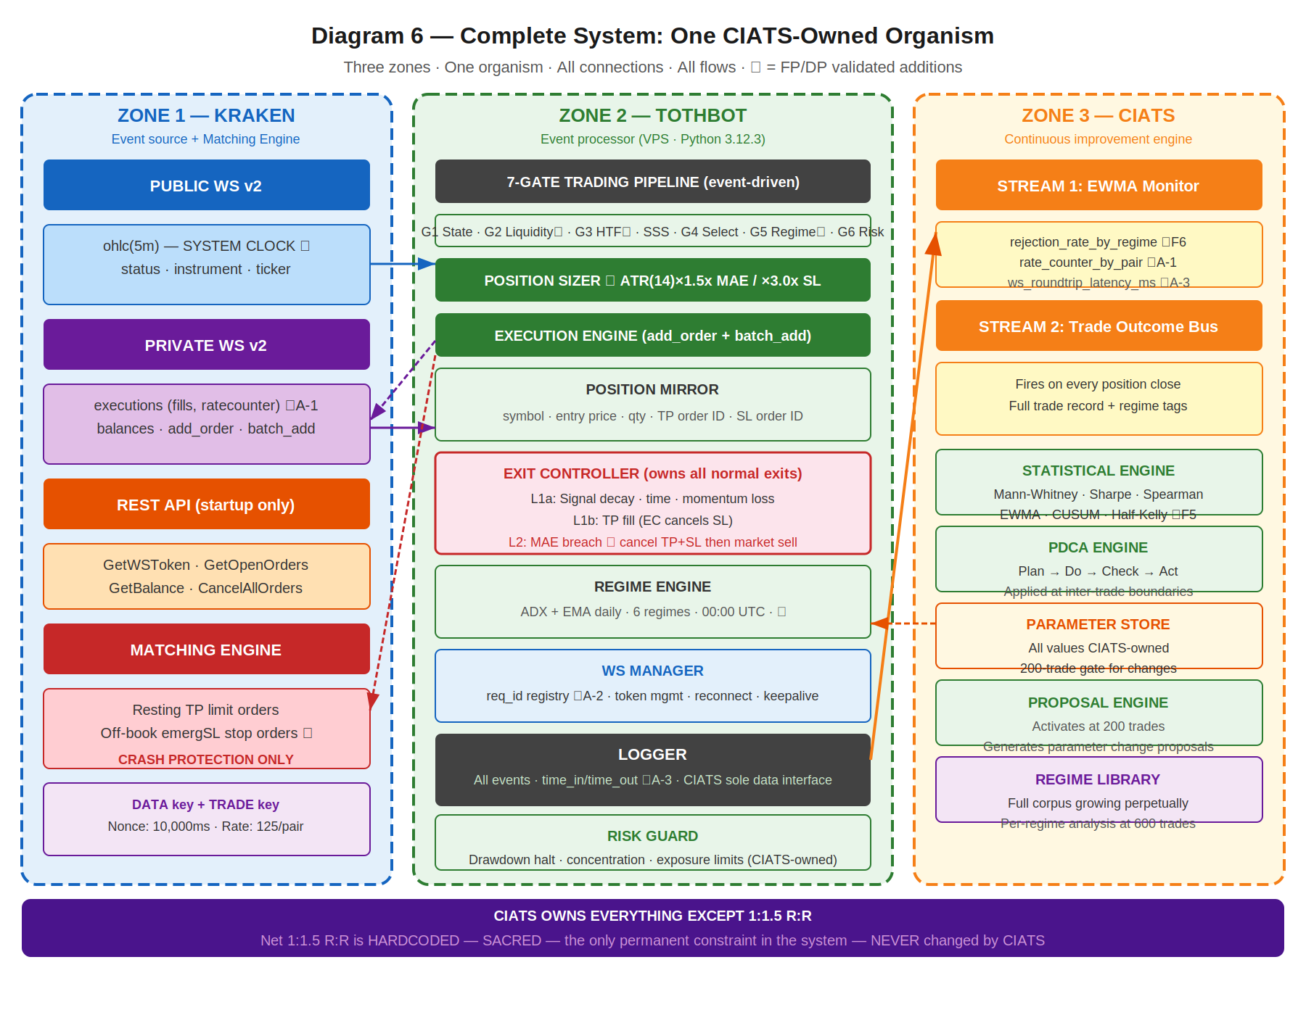

CIATS OWNS EVERYTHING EXCEPT 1:1.5 R:R All parameters, thresholds, sizing decisions, halt thresholds, multipliers, and trading rules are CIATS-owned starting values. They will be replaced by data-driven values during paper trading and live trading. By end of paper trading, all starting values will have been validated, corrected, or confirmed by real market data under Deming PDCA governance.

8. Locked Architectural Decisions

ID | Decision | Specification
AR-001 | No Dead Man's Switch | Resting TP limit orders and off-book emergency SL stop orders on Kraken matching engine ARE the crash protection. No separate DMS thread.
AR-002 | Position Mirror | Symbol, entry price, qty, TP order ID, SL order ID. Kraken-event-driven.
AR-003 | Restart reconciliation | REST GetOpenOrders + GetAccountBalance → verify SL orders → re-submit missing → then begin signals.
AR-004 | Two API key pairs | DATA key (market data) + TRADE key (orders + WS auth). Nonce window: 10,000ms on both.
AR-005 | WS v2 only | WS v1 not used. All future Kraken enhancements go into v2 only.
AR-006 | Entry order type | WS add_order: limit, post_only=true, GTD, expiretm=now+30-60s. CIATS-owned timeout.
AR-007 | TP placement | Resting limit via WS batch_add on entry fill. Maker fee 0.16%.
AR-008 | Emergency SL placement | Stop-loss market via WS batch_add with TP in single atomic message. ATR(14)×3.0x.
AR-009 | Short deferred | Kraken Derivatives US CME futures. $1,000 below margin. Activates when conditions allow.
AR-010 | 24/7/365 | No stand-down. CIATS adds via PDCA only if data supports after 200 trades.
AR-011 | Net 1:1.5 R:R — SACRED | Only hardcoded constraint. Dynamic formula. NEVER changed by CIATS.
AR-012 | Fee baseline | Maker 0.16% / Taker 0.26%. CIATS monitors actuals.
AR-013 | Kraken Pro — Intermediate | Confirmed sufficient for all required API permissions.

9. Complete CIATS Parameter Registry

ALL PARAMETERS ARE CIATS-OWNED STARTING VALUES CIATS owns all parameters after 200-trade gate. No ceilings. No required safety reviews for sizing changes. Deming PDCA governs every change. 1:1.5 R:R net is the only exception.

Parameter | Starting Value | CIATS Changes When...
tradeable_pct | 50% of portfolio | Drawdown analysis shows over/under-exposure.
per_trade_pct | 5% → Half-Kelly at 200 trades | Kelly criterion diverges. Updates every 50 trades thereafter.
max_concurrent | 20 positions | Concentration data shows optimal concurrency.
mae_mult (ATR×) | 1.5× ATR(14) | Actual MAE distribution clusters above/below. Mann-Whitney.
emergency_sl_mult | 3.0× ATR(14) | Ratio to MAE must remain ≥2×. Tail event distribution.
entry_timeout_sec | 30-60s GTD | Skip rate analysis vs fill opportunity. Spearman.
full_halt_drawdown | 10% of portfolio | Portfolio volatility distribution analysis.
session_pause_drawdown | 5% of portfolio | Session loss distribution. Mann-Whitney.
signal_thresholds | SSS gates (derived) | Signal cohort win rates diverge. Mann-Whitney.
adx_threshold | 25 | Regime classification accuracy vs trade outcomes.
atr_percentile_threshold | 67th | Vol regime accuracy vs outcome distribution.
htf_ema_periods | 20/50 daily | 1H HTF gate rejection vs signal quality outcomes.
min_volume_usd_daily | $500k USD | Post_only fill rate and SL quality vs volume floor.
1:1.5 R:R net | HARDCODED — SACRED | NOT CIATS-OWNED. The only permanent constraint in the system.

10. Six FP/DP Validated System Improvements
Derived from 80+ sources across 3 independent research passes. 5+ sources per parameter. Nothing added without data. Nothing changed without justification.
Finding 1: 1H HTF Confirmation Gate [TothBot]
Gap: | No layer between daily regime and 5-min entry.
Evidence: | 15-20% higher win rates with daily+hourly filter (5 independent sources 2024-2025).
Change: | Require 1H EMA(20)>EMA(50) for TRENDING_POSITIVE entries. Skip logged as HTF_GATE_REJECTED.
Effect: | Removes false signals during 1H pullbacks within daily uptrends. Zero API cost.

Finding 2: ATR Dynamic Stop Distances [TothBot/Exit]
Gap: | Fixed 2% stop ignores real-time market volatility.
Evidence: | +15% performance, -22% max drawdown vs fixed stops (LuxAlgo backtesting + 4 other sources).
Change: | MAE: ATR(14)×1.5x. Emergency SL: ATR(14)×3.0x. Both CIATS-owned starting values.
Effect: | Stop adapts to conditions. R:R formula preserved. Exit Controller fires before emergency SL.

Finding 3: Regime Gate [TothBot]
Gap: | Long momentum system trading in absent-edge conditions.
Evidence: | Accuracy 65%→45-50% in NON_DIRECTIONAL (Market Cipher). Break-even 40% for 1:1.5 R:R.
Change: | NON_DIR+ELEV and TRENDING_NEG: no entry. NON_DIR+NORM: 50% size.
Effect: | Stops trading when documented edge is absent. Pure loss minimization.

Finding 4: Minimum Liquidity Gate [TothBot]
Gap: | No minimum 24h volume on asset selection.
Evidence: | $1M+/day minimum for clean execution (Coin Bureau + 4 sources 2024-2025).
Change: | Asset Registry adds min_24h_volume_usd $500k starting. Checked daily via ticker.
Effect: | Protects fee formula. Ensures clean post_only fills and SL execution.

Finding 5: CIATS Half-Kelly Pathway [CIATS]
Gap: | Fixed 5% sizing had no defined data-driven transition.
Evidence: | Half-Kelly: 75% optimal growth at 50% less drawdown (MacLean-Thorp-Ziemba + 4 sources).
Change: | At 200 trades: K%=W-(1-W)/R, apply 50%. Update every 50 trades. No ceilings.
Effect: | Data-driven sizing replaces arbitrary fixed fraction after sufficient data.

Finding 6: post_only Rejection Monitoring [CIATS]
Gap: | Rejection events logged but unused by CIATS EWMA.
Evidence: | Rejection rate = direct signal of entry placement quality (Cube Exchange + 4 sources).
Change: | CIATS EWMA adds rejection_rate_by_regime stream. High rate in TRENDING = miscalibrated.
Effect: | Free diagnostic signal already in Logger. Entry optimization pathway activated.

11. Complete Trade Lifecycle — Narrative Reference

11.1 Normal Trade (Entry → TP or Exit Controller)
OHLC 5-min candle close fires on public WS v2
State Machine: online or post_only → continue; else halt and wait
Liquidity Gate: 24h volume ≥ $500k → continue; else skip
1H HTF Gate: 1H EMA(20) > EMA(50) for TRENDING_POS → continue; else skip
Signal Engine: SSS score computed on 5-min candle
Selection Controller: 6-gate quality evaluation → pass or reject
Regime Gate: TRENDING_POS: proceed; NON_DIR+NORM: 50% size; else block
Risk Guard: drawdown/concentration/exposure checks → pass or halt
Position Sizer: MAE = ATR×1.5x, emergSL = ATR×3.0x, TP = R:R formula
Execution: WS add_order (limit, post_only, GTD expiretm=now+30-60s)
If expired/rejected: log reason code → CIATS EWMA monitors rejection rate. Done.
If filled: WS batch_add → TP (resting limit) + emergSL (stop-market) atomic
Position Mirror records: symbol, entry, qty, TP order ID, SL order ID
Exit Controller monitors. Logger records full entry. CIATS Trade Outcome Bus ready.
TP fills: EC cancels emergSL. Or EC fires Layer 1/2 exit. Position closes.
Logger records full exit. CIATS Trade Outcome Bus fires with complete trade record.

11.2 Layer 2 MAE Exit (Adverse Price)
Exit Controller detects: current_price - entry ≥ ATR(14) × 1.5x
WS cancel_order: cancel TP resting order
WS cancel_order: cancel emergSL stop order (off-book) ← sequence critical, both before market sell
WS add_order: market sell (taker 0.26%)
Logger: exit reason = MAE_THRESHOLD_BREACH
CIATS Trade Outcome Bus fires

11.3 Emergency SL (Layer 3 — System Failure Only)
VPS crashes / TothBot dies / internet severs / unrecoverable WS disconnect
Kraken matching engine fires off-book emergency SL stop-market order at ATR×3.0x
On restart: reconciliation detects closed position → Logger: EMERGENCY_SL_FIRED
This is a system failure event requiring investigation. Should NEVER fire in normal operation.

12. Open Items — Require Specification Documents

# | Item | Description
001 | Signal generation (SSS) | SSS scoring model re-derived from first principles for Kraken Spot.
002 | Asset selection universe | Kraken USDT/USDC pairs — eligibility criteria beyond liquidity gate.
003 | Exit Controller spec | Complete: signal decay thresholds, time exit rules, momentum detection, full L1/L2 decision tree.
004 | Entry limit placement | Exact rule for post_only limit price relative to bid/ask spread.
005 | Selection Controller | 6-gate formal specification.
006 | CIATS specification | Full spec: all interfaces, methods, PDCA workflows, regime library format.
007 | AA=04 Exchange Interface | Formal controlled document incorporating all decisions in this overview.
008 | All AA=10 coding specs | Full coding specs for every module, infrastructure component, and test suite.

13. Revision History

Version | Date | Description
dv1_0 | 03-23-2026 | Initial document. All architectural decisions, FP/DP improvements, exit architecture ground zero redesign, regime taxonomy, CIATS ownership model, and complete system flow.
dv1_1 | 03-23-2026 | Added all six system flow diagrams: (1) Kraken API connections, (2) trading pipeline with all gates, (3) exit architecture three layers, (4) regime taxonomy grid, (5) CIATS data flows, (6) complete one-organism system.
dv1_2 | 03-24-2026 | Six changes from deep API validation search. (C-1) Emergency SL terminology corrected throughout: stop orders are off-book contingent instructions held by Kraken matching engine, not resting visible book orders. Term "resting" now reserved for TP limit orders only. (C-2) Intermediate tier rate limits added in new Section 2.3. (C-3) OHLC fires on trade events not wall clock — note added to Section 3. (A-1) ratecounter:true enabled on executions subscription. (A-2) req_id mandatory on all outbound WS messages. (A-3) time_in/time_out WS response latency logging added. Open item 008 AA=11 corrected to AA=10.
dv1_3 | 03-24-2026 | Rebuilt as correct .docx with all six diagrams embedded. dv1_2 was produced in error without diagrams (Claude.ai platform stripped binary content from uploaded .docx). All dv1_2 text changes are present and correct. Diagrams recreated from SVG source files and embedded as PNG images. This is the first complete and correct version of the document with both all dv1_2 content and all diagrams intact.

